Kumikumi mo e Liu Kitekite ke he puhala fakagahua he tau tupe ke moua e fetataiaki he tau totogi he tau faahi gahua fakaako mo e leveki mo e tau fale fakaakoaga fakamahani ne kua laisini - Ko e tohi he Fakakatoatoaaga he tau fakatutalaaga

Kamataaga
Hae ne fae fakatutala e Faahi Ikipule hagaao ke he taha fakataitai ke lagomatai ke fakagahuahua e fakatatai he tau tupe moua mae tau faiaoga ne kua moua e tau tohi setifikete he faahi fakaako mo e tau levekiaga (lalafi ki ai e tau gahua ne toka ai ke he tau fale gagao) mo e ha lautolu a tau hoa gahua he tau aoga fakamahani. Ko e taha vala he fakataitai nei ke lafi ki ai e tau totogi ia lautolu ne gahua mae tau gahua ne taute ke he loto kaina.
Ki lalo hifo he tau puhala fakatupe ke he magaaho nei, ne fekehekeheaki e tau lagomatai tupe mae tau fakaakoaga mo e tau gahua leveki kaeke ke kehekehe e tau fanau ne o atu he aoga mo e tau faiaoga ne kua moua e tau setifikete mo fakaaoga ke fakaako aki e tau fanau. Nakai la leva ia he mole, kua maeke e tau kau gahua ke fifili ki ai ke he tau launi totogi tupe ne lahi hake e fetataiaki kaeke ke fakamooli ke totogi e tau faiaoga aki e tau launi totogi ne tohia ke he Collective Agreement KTCA) tuga ko lautolu ia ne haha ki ai ko e tau Faiaoga Fakamahani (Kindergarten Teachers), tau Ulu Faiaoga (Head Teachers), mo e tau Faiaoga Motua (Senior Teachers').
Ne paia he puhala fakagahua ainei ati nakai mukamuka ke folafola mai e tauteaga ke fetataiaki e tau tupe moua he tau totogi. Ko e pihia ha kua nakai taui mitaki e tau launi fakatupe ne kua laulahi ki ai he taha e tula ke he hikiaga he totogi vahaloto he faiaoga ne gahua tokotaha. Ko e kakano he mena ia ha kua lahi atu e tau tupe moua he falu ha ko e tau launi tupe ne fakafetataiaki ka kua nakai lata, ka e ko e falu to nakai moua lauka.

Ko e Kumikumi mo e Liu Kitekite ke he Tau Tupe ke moua e Fetataiakiaki he tau Tupe Moua (The Review of Funding for Pay Parity)
Ko e kakano mo e laulahi he onoonoaga he Kumikumi mo e Liu Kitekite
Ne hataki he Ikipule he Faahi Fakaako Tama e Faahi Fakaako Tama ke taute e taha gahua ke kumikumi mo e liu kitekite ke he tau tupe fakagahua ke kitia mo e fakagahua e taha puhala ke fakatatai e tau tupe moua ke lata mae tau fakaakoaga mo e tau gahua leveki ke he tau totogi he tau faiaoga ne kua moua e tau setifikete.
Ko e laulahi he onoonaga he gahua Kumikumi mo e Liu Kitekite (Review) nei ne putoia fakalataha e tau fakaakoaga mo e tau levekiaga mo e tau gahua ne tauteute ni ke he tau lotokaina.

Ko e tau matapatu fakaakoaga ma e Kumikumiaga Liu Kitekite
Mailoga he Kumikumiaga Liu Kitekite e tau matapatu fakaakoaga mo e tau fakatokatokaaga ke he laulahi he tau puhala fakaako ke moua tupe. Ke fakatai ke he tau matapatu fakaakoaga nei: ha kua veveheua he fakatufono mo e tau mamatua e totogi mae tau fakaakoaga kamata fakamua, ko e tau matutakiaga he tau fafatiaga leveki, ko e tau fakatupe ne uta ni ke he tau fanau ne o atu he aoga, mo e taofi mau ke he tau tula ne fai kaupaaga he faahi tapu mo e aho.

Ko e tau fakatokatokaaga pauaki mae fakatataiaga he tau tupe moua gahua ne kua omoomoi ke he tohi fakataitai ne kua fakatata. Ko e tau mena nei ne putoia ki ai: ke liu tufatufa e tau matapatu tupe ne fita e haha i ai ke lalafi ke he matapatu (ECE Subsidy mo e 20 Hours Subsidy), pihia foki mo e ha tupe moua ke he tau magaaho i mua ne ligaliga ke fakapuni aki e veha he tau totogi gahua, mo e ke fakatatai oti e tau launi totogi gahua ke he tau tula oti ne gahua ai e tau faiaoga, nakai ni ke he tau tula ni ne totogi he fakatufono.

Ko e fakataitai - Tau fakaakoaga mo e tau faahi gahua leveki
Kua putoia kehe fakataitai ke taui ua e tau matapatu tupe lagomatai ke lata mae tau fakaakoaga mo e tau faahi gahua leveki (ko e ECE Funding Subsidy mo e tupe lagomatai ke he 20 Hours ECE) mo e ua e tupe lagomatai foou.
- Ko e Teacher Salary Subsidy (TSS): ko e lagomatai ne laulahi e fakafifitakiaga he fafatiaga tupe ke he tonuhiaaga he faiaoga ne gahua katoatoa e tau tula mo e kua moua e laupepa he katoatoa e tau fakaakoaga (FTTE) ne kua tufatufa ke he tau faahi gahua mo e tau totogi ne kua laulahi ki ai e tau faiaoga he tau faahi gahua. Ko e maeke ni e tau tupe lagomatai nei ke fakaaoga ke he tau totogi gahua he tau faiaoga.
- Ko e taha vala tupe fakagahua (Operating Subsidy)(OS): ko e tupe lagomatai ne totogi ke he taha fafatiaga kua mau nakai hiki he taha e tula tama.
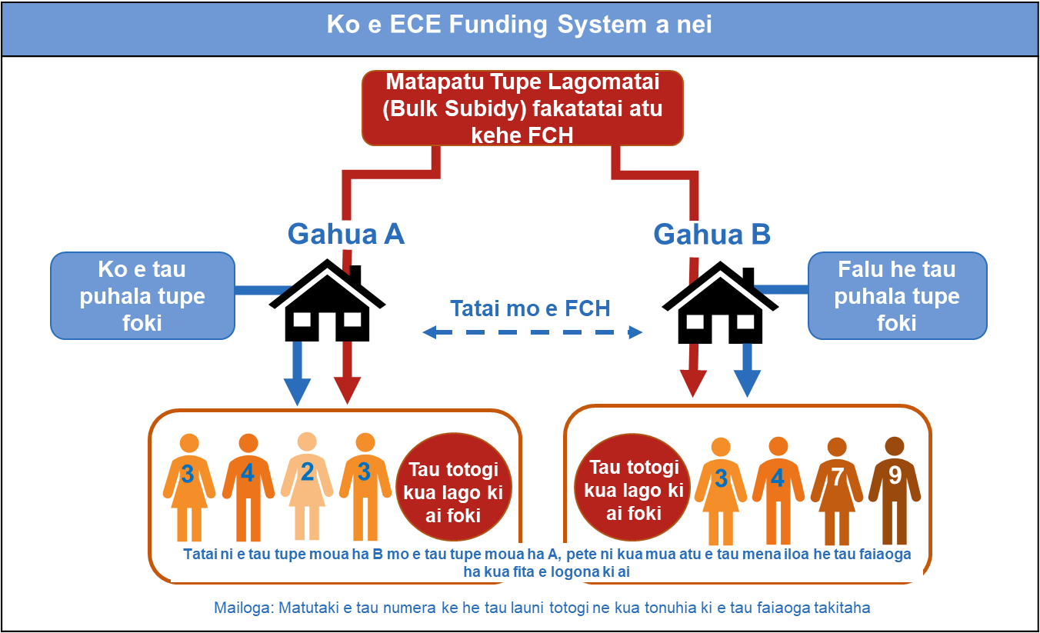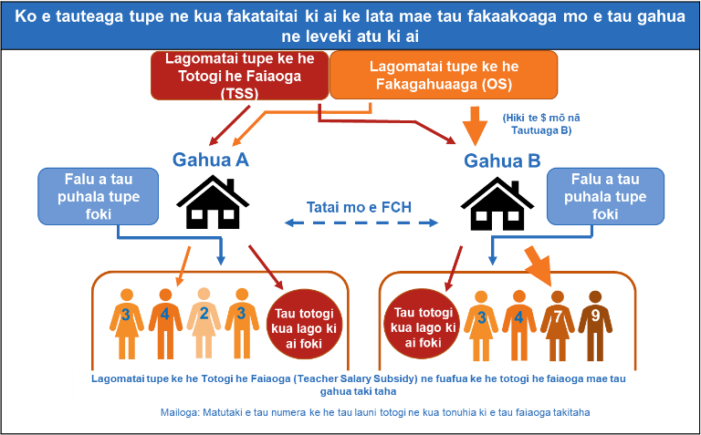
Element 1: Lafilafi e tupe kua lata ke moua ko e FTTE ke lata mae tupe lagomatai mae faiaoga (Teacher Salary Subsidy).
(poke 'fiha e faiaoga ka lalafi ki ai (‘how many teachers will be included’)
Ko e lakaaga fakamua ke iloa e TSS ke lata ma e tau faahi gahua ne kua lata ke kumikumi ke iloa e tonuhia ke tau lagomatai FTTE he tau faiaoaga ne kua moua e tau laupepa fakaako. Kua fakataitai e tonuhia nei ke he tau tupe lagomatai nei ke lafilafi ke iga ni he tau faahi gahua ne kua fakafifitaki ki ai:
- Forecast FCH: Ko e numela ne kua talimanatu numela ki ai he tau fanau ke lagomatai ke totogi e tau tula (FCH) ke he fa e mahina ne kua fafati ki ai.
- Ko e fafatiaga ne kua tonuhia ki ai (entitlement ratio):Ko e numela tama ne kua fita e fakamau ke he tau faiaoga ne kua moua e tau laupepa ke he taha magaaho tonu ni. Ka mitaki atu e numela fafati, to tokologa atu e tau faiaoga ka putoia ke he FTTE ne tonuhia ke moua ke lata mae fakatataiaga ke he tau numera FCH. Ka fakatokatoka e taha fafatiaga ne fa mahani ki ai ke lata mae TSS to fetataiaki foki e tau puhala leveki.

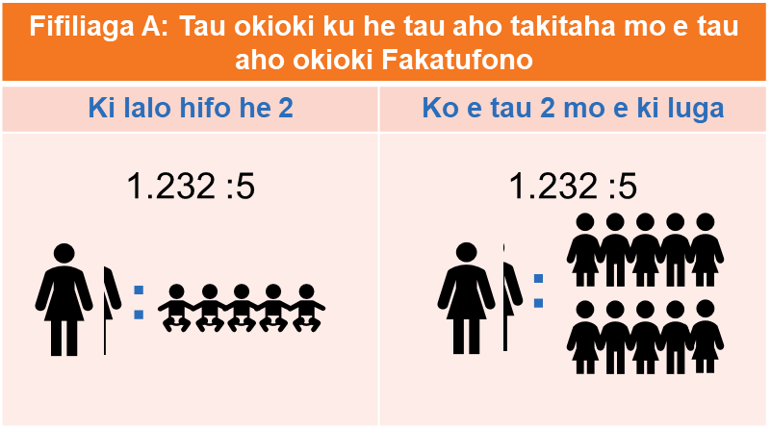
Ko e tau fakapapahi ne maeke ke fakatokatoka ke lata mae fafatiaga kua tonuhia ki ai (Entitlement)
Manatu a mautolu kua maeke e fafatiaga ke fakatokatoka puhala ai ke he taha mai he ua e fifiliaga. Kamata e tau mena nei mo e tau fafatiaga ne fai falanakiaga ki ai ko e matua-ke he-tama ke kamata aki ka e fakagahua ni ke he tau faiaoga ne kua moua e tau tohi fakaako ka e nakai ke he tau tagata lalahi.
Option A: ko e taha 'puhala tote ne kua fakamau ai he fakatufono' (statutory minimum) approach, ne putoia e tau fakamauaga nofo okioki mai he gahuaaga mo e tau magaaho okioki ne kua lata ke igatia he tau FTTE. Moua mai he mena nei e taha fafatiaga ko e 1.232 e tau tagata lalahi ke he fakatai ko e 5 poke 10 e tau fanau (uta ni ke he tau fufuta he tau tau moui ki lalo hifo he 2/kia lautolu 2 ki luga e tau tau moui).

Option B: taha fafatiaga ne molea e 1.232 e tau tagata lalahi ke he tatai ni e tau numela tama. Ko e fifiliaga nei ne kamata ke totou ki ai e totogi he tau fifiliaga fakagalogalo (tuga ai nei, tau tula ne nakai fai matutaki mo e tuku ni fakamahao ke muitua ke tau fafatiaga ne kua fakamau mo e mumuitua ki ai).

Element 2: Lafilafi e tau tupe mae tau levekiaga ke lata mae Teacher Salary Subsidy
Mumui mai e tau tutuaga he tau kotofaaga takitaki ha ko e tau tapakiaga he tau fuafuaaga ke he tau tupe fafati ne moua. Kua fakafifitaki e tau mena nei ke he tau gahua takitaki gahua KTCA 'K2-K4'.
- K2 - fakagahua ke takitaki ke he taha faahi gahua, mo e nakai ko e tau tagata gahua K3 poke K4 (tuga e, takitaki gahua lahi).
- K3 - fakagahua ke lagomatai ke he tau tagata gahua, ke tuku age e tau hatakiaga mo e tau gahua leveki ke he tau fakaholoaga he tau ofisa. Lago ki ai e takitakiaga ke he fufuta he tau tagata gahua K2.
- K4 - fakagahua ke lago ki ai e levekiaga ke he tau tagata gahua ne nonofo ke fufuta K3.
Ne haha i ai ke he fakataitai ua e fifiliaga ke moua e levekiaga ke he tau tupe moua mo e tau gahua takitaki:
Option A: Ko e fifiliaga ke he K2-K4. Ke he fifiliaga nei, to mailoga he tau fakaakoaga mo e tau gahua leveki e tau faiaoga ne kua moua e tau tohi fakaako ki loto he tau gahua takitaki ne ha ko e tau fufuta totogi K2, K3, mo e K4 he KTCA. Ko e fafatiaga pauaki (FTTE entitlement) to lafilafi ke iloa ko e fiha e FTTE ke lata mae tau pu gahua ne fakatupe fakaaoga he taha fafatiaga ne leveki ki ai.
Fakatokatoka e fafatiaga takitaki
Ko e fafatiaga takitaki pauaki he Option A ne kua lata ke set ke he taha fakatino fakatata na i lalo. Ko e tama ne kua moua e puhala lagomatai ne haha i ai e atiaga tupe ke lagomatai atu ke he fafatiaga foou nei mo e ke fakamahino ko e 75,000 he tula totogi ke moua e levekiaga he tau fanau he taha e tau. Ko e tau faahi lagomatai ni ne loga atu mai he taha e faahi gahua ne gofua ke moua e fafatiaga tupe K3 mo e K4.
Ko e fufuta totogi he tau takitaki | Fatifatiaga
K2 | 1:50 (levekiaga FTTE ke he tau fanau ne kua moua e tau tupe lagomatai)
K3 | 1:300 (levekiaga FTTE ke he tau fanau ne kua moua e tau tupe lagomatai)
K4 | 1:6 (Fafatiaga K4 he K3)

Option B: Ko e K2 mo e levekiaga he fifiliaga ke he tau tupe lagomatai. Ke he fifiliaga nei, igatia e tau faahi fakaako mo e leveki to tukutuku ke he taha e tuaga K2 totogi ke he fufuta tokoluga mai he fufuta totogi he K2. Lalafi ki ai, to atihake e tupe lagomatai mae tau levekiaga ne totogi e tau faahi leveki e taha fufuta ke he taha e FCH mo e gahuahua fakafifitaki ke he lahi he tau FCH ka hoko mai e tau magaaho ke moua e tau tupe lagomatai. To nakai fakatupe ke tuga e tau fafatiaga kua mau ai ke tuku hake e tau totogi, ka e, to taute fakakehekehe e tau fakatupe he tau faiaoga ne kua moua e tau kala tohi ne kua fakagahua ke he tau gahua takitaki.

Element 3: Iloa fakamooli e tau tupe ne fakatupe-aki e puhala he TSS
Ko e magaaho ne kua lafilafi e tau Elements 1 mo e 2 ke lata mae taha gahua ne kua fakafita ki ai, fakataitai a mautolu ko e fakatupe he fakatufono ke lata mae TSS ke he tau mahina ke fa aki oti to fakatatai atu ke he tau lakaaga na ne mumui mai.
- Ko e tauteaga ke he taha totogi tukutuku fakatatai e tau mamafa (fakatokatoka ke he tau fafatiaga totogi he KTCA) mae FTTE he faiaoga i loto he gahua he magaaho.
- Fakatatai e FTTE kua tonuhia kia ai ke he FTTE mooli mae taha gahua. Kua lafilafi pehe nei e pasene he taha faiaoga ne gahua ne kua moua e tau tohi fakaako.
- Tukutuku hifo e tau numela he tau FTTE ke fakakite e fakatupe-vala ni e tau tula tama (ha ko e mena ko e vala ni ne totogi ke moua ne fakatupe mae tau tula he magaaho nei mae ECE Subsidy). To fakaaoga he mena nei e taha fafatiaga ne kua fita e fakatoka ke kitia e fakatino he fakatupe-vala.
- Lalafi fakalahi e fafati tonuhia FTTE, lalafi ki ai e tau FTTE ne kua hikihiki, he taha faiaoga a totogi ne laflahi ke he tau sitepe na i luga, ke moua e vala ne nakai leveki he faiaoga e vala TSS.
- Iloa tonu e levekiaga ke he tau tupe (onoono ke he Element 2). To tukutuku hifo foki e levekiaga ke he tau tupe ke kitia e tau tula tama ne kua fakatupe-vala, ke fakatatai atu ke he puhala he Step 3.
Ko e fakatupe TSS to 'nakai malolo' ka hoko atu ke he fakaotiaga he magaaho ne kua fafati ki ai ke mailoga e tau fekehekeheaki he tau tupe moua mooli mo e tau tupe moua ki mua ne kua iloa tuai. Ko e puhala pehe nei ni ne fakaaoga ke hiki e tau lagomatai fakatupe ke he tau fakaakoaga he magaaho nei.
To iloa ko e fakaaogaaga fefe e totogi ne mamafa fakalatalata he taha gahuaaga TSS? (Step1)
Kua lata ke fai he Step 1 ne mamafa fakalatalata e totogi (ne fakatatai mo e tau totogi KTCA) mae tau gahua taki taha. Ko e fakatai ne kumikumi ke moua e tau fakakite manatu hagaao ke he ua e tau puhala ne kua maeke ke fifili aki e mamafa fakalatalata:
- Fakatatai ke he tokologa e totogi he tau faiaoga oti ne fai setifiketi ke he taha gahuaaga ke he tau magaaho ko e fa e mahina. To fakamamafa mo e fifitaki ke he FTTE ne kua fakagahua pauaki e faiaoga ki ai.
- Fakaata ke he tau gahua ke fifili ko e tau FTTE faiaoga fe ka fakatupe mai he tupe TSS ne kua tonuhia ki ai. To fai ufiufiaga e gahuaaga ko e fiha e FTTE he faiaoga ka lalafi ki ai.
Fakatatai fefe e FTTE he tau faiaoga ke he FTTE ne kua lata ke moua? (Step 2)
Kua kumikumi e fakatai nei ke moua e tau manatu fakakite ke lata mae e tau puhala taute ne kua maeke ke iloa ko e fakamooli fefe he gahuaaga e FTTE ne kua tonuhia ki ai - ko e taha mena nei ne onoono ke he taha vala numela he tau faiaoga ne kua moa e tau tohi fakaako (tatai mo e tau faiaoga ne kua moua e tau fufuta tohi fakaako ne haha ki ai he puhala gahua ai nei):
- Fakaaoga e FTTE katoatoa he faiaoga ne kua gahua he magaaho kua lata ke moua e taha fafatiaga ke falanaki ki ai ke he tau tula he tau fanau ne faka-tupe mo e nakai faka-tupe.
- Fakaaoga e tau matafakatufono 'totou e tau tula he tagata gahua' ke fakatatai e tau tula he faiaoga ke he tau tula he tau tama - ko e fakaholoaga nei ne totou e tau faiaoga ne kua moua e tau tohi mo e kua lahi atu e fakaaoga ke he fifiliaga fakamua. Fakaaoga he fifiliaga nei e tau FTTE fakagahua ne lahilahi hake fakatote ke fakaaoga e tau FTTE ne kua tonuhia ki ai.
Ko e vala ne fakatupe he papiliki ke lata mae tau tula ne nakai totogi katoatoa (Steps 3 mo e 5)
Ko e Step 3 he puhala fakatupe TSS ne kua tukutuku hifo e tonuhia ke he FTTE ha kua tuku ni e taha vala. Ko e vala nei to fakakite e lagomatai he fakatufono poke papiliki ke he tau tula gahua ne nakai totogi katoatoa. Ko e vala fafati nei ne kua fita e fai ke he totouaga, ka kua nakai fai pasene tonutonu ne kua fakatoka ki ai. Ko e fakatokaaga he vala fafati nei ne lauia ai e veheveheaga he tau tupe lagomatai ki loto he TSS mo e OS. Ko e tau tupe lagomatai katoatoa ke lata mai ma e tau gahua oti to tumau ke tatai ha ko e mena ko e taha manatu uho a nei he tohi fakatai. Kua fakatutala a mautolu hagaao ke he ua e puhala ke fakagahua aki e lagomatai mai he papiliki.
Fifiliaga A: Taha fakatokaaga he fakatufono mae taha vala fafati ke tuku ke he tau tula gahua ne ai katoatoa e tau tupe. Kua onoono fakalahi ke fakatokatoka e vala fafati nei ke 80% mo e taha 20% taha foaki fakagalogalo (tuga mai he tau tupe mai he tau mamatua).

Fifiliaga B: Fakatumau ke mau e tau foakiaga fakagalogalo pete ni ko e totogi he laulahi he tau faiaoga. To eke e mena nei ke tokamau ni he taha e fafatiaga he tau foaki fakagalogalo pete e laulahi ke tatai e tau fafatiaga totogi ke he gahua. Ko e kakano he mena nei, fakatai ki ai, kaeke ke totogi $10 he tula ke fakagahua e faiaoga, to liga ke lagomatai ki ai he fakatufono $8 kakano ia kua lata he faahi gahua ke foaki $2. Kaeke ke hake e totogi he tau faiaoga he faahi gahua ke he $20 he tula pete e tumau agaia e tonuhia ke he FTTE, to fakatupe he fakatufono $18 mo e fakatumau agaia ni e faahi gahua ke foaki $2.
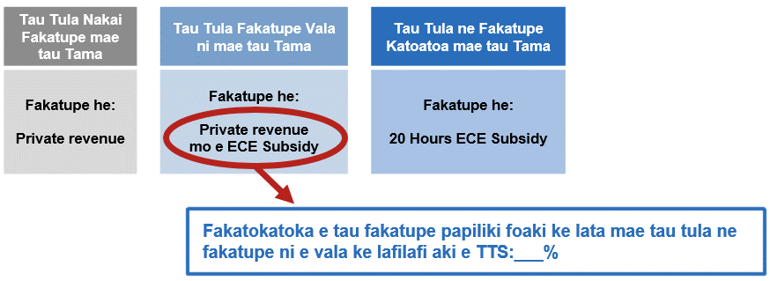
Element 4: Lafilafi ke he Tupe Lagomatai Fakagahua (Calculating the Operating Subsidy)
Kua fakatoka he fakataitai nei e Tupe Lagomatai Fakagahua (Operating Subsidy) ke lata mae tau mena totogi he tau faahi gahua ke he tau fakaakoaga mo e tau levekiaga. To totogi ko e fafatiaga tupe he tula ke lata mae tau faahi gahua oti. To taofi he tau faahi gahua nei ke maeke ke hikihiki ke he tau puhala ke fakaaoga aki e Tupe Lagomatai Fakagahua poke OS.
Ko e uta ni e fafatiaga totogi he OS ke he manako katoa he TSS ke lata mae tau faahi gahuaaga oti. Kua pihia e mena nei ha ko e tupe lagomatai katoatoa ke lata ma e tau gahua ke he TSS ka lafilafi fakamua mo e ko e heigoa ni ne toe ke fakaaoga ke lafilafi aki e fafatiaga OS. Ko e fakatokaaga he TSS ne kua fakatutala ki ai fakamua ne fakatoka ke he taha puhala ne fakaata ke moua e taha TSS lahi atu, ti ko e tau fafatiaga OS ka moua mai kua lata ke tuku fakatokolalo atu mai ia lautolu ane mai kua tote hifo e TSS.

Uta kehe e 'ki lalo hifo he 2' mo e '2 ki luga' ne fekehekehe ai
Ko e fafatiaga OS to nakai maali e tau fafatiaga 'ki lalo hifo he 2' mo e fafatiaga '2 ki luga' Ko e fekekekeheaki he tau tupe moua he tau fafatiaga he puhala gahua ne tuku ki loto ke fakakite e tau fekehekeheaki he tupe ka fakaaoga ke he tau faiaoga ne kua fai seifikete ke gahua ha kua kehekehe e tau fafatiaga ne hataki ke he tau tau moui kehekehe. Ne mailoga he TSS e tau fekehekeheaki he tau totogi he tau faiaoga ne lauia mo e tau fatifatiaga kehekehe (tuga e numela kehe he faiaoga ke lata mae tau vahega tau tau moui kehekehe). Kua fakaata e OS ke fakailoa fakamahino ko e fafatiaga ne totogi katoatoa mo e fafatiaga ne totogi vala.
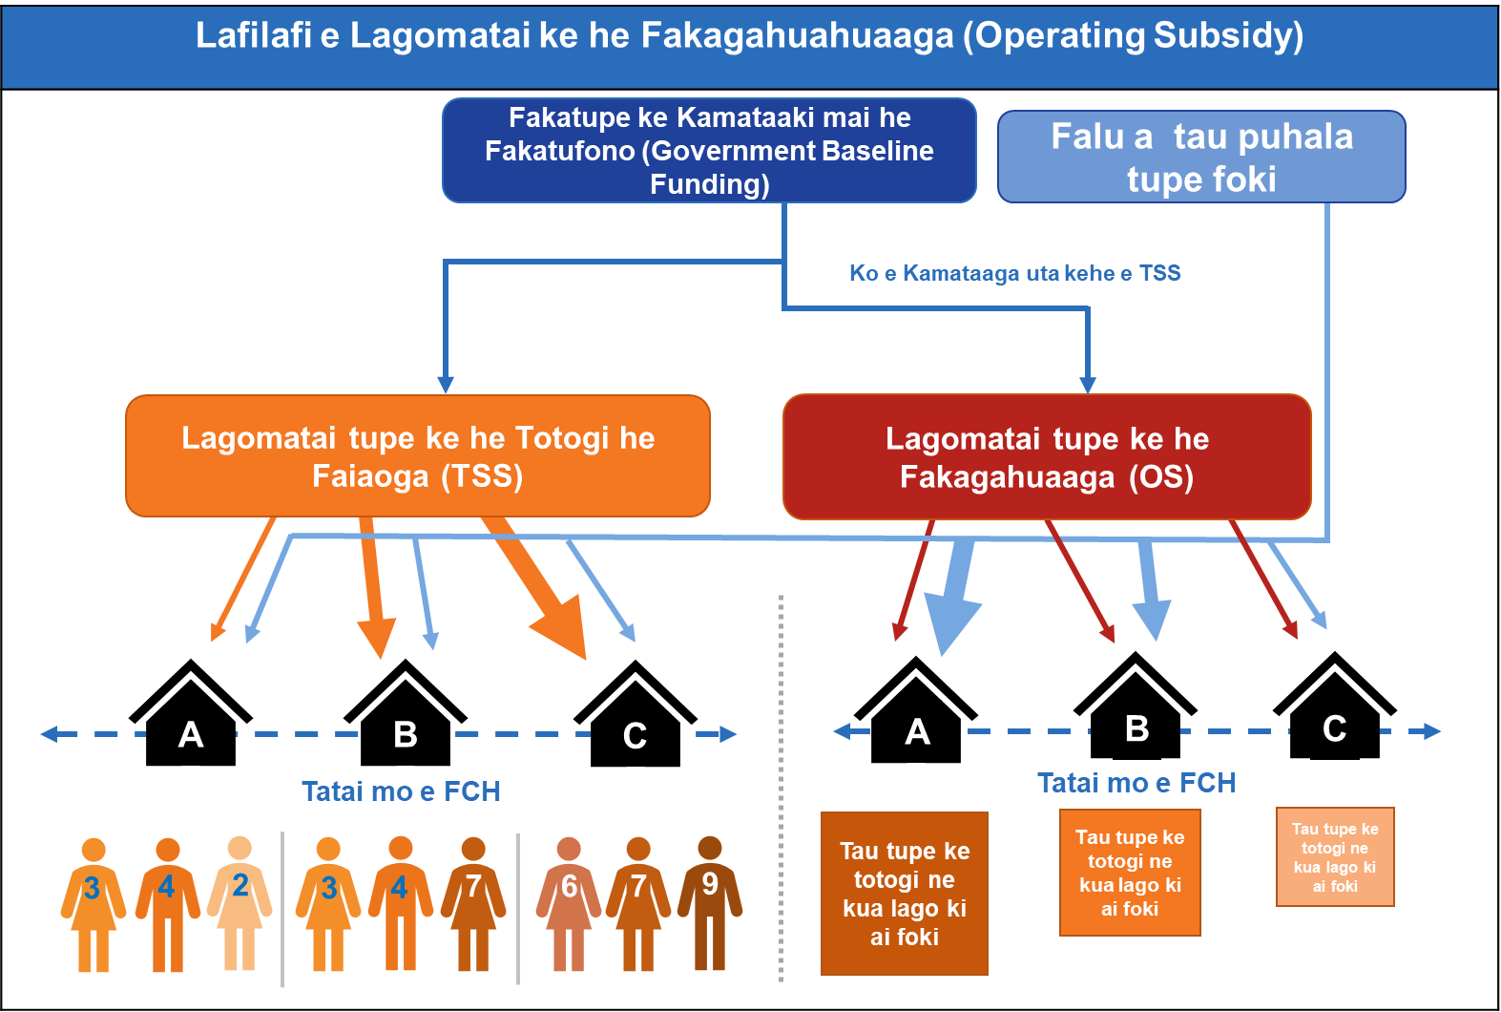
Ko e tau lauiaaga ke he tau tupe lagomatai ke he tau faahi gahua h ko e puhala gahuahua ne kua fakataitai ki ai.
Ko e puhala foou to hiki e tau tupe lagomatai ke he tau faahi gahua mai he fakatufono ke he FCH - ke he falu to tose hifo e tupe lagomatai he taha e tula ke lata mae gahua ke fakatatai ke puhala gahua ke magaaho nei. Ko e tau faahi gahua ne kua ligaliga ke hikihiki ha lautolu a puhala fakagahuahua ke maeke ke leveki ke he tau hikihikiaga nei. Ko e puhala foou, ne gahua fakalataha mo e tau manako ke fakatatai e tau totogi, ne taofi fakalahi mo e nakai mukamuka ke hikihiki ha kua fakaaoga oti e ha lautolu a tau tupe moua lagomatai ha kua fakaaoga e TSS ke totogi aki e tau faiaoga. Ko e kakano he mena nei, tuga e, ko e faahi gahua ne molea e fakagahuahuaaga ke he tau fafatiaga he tau faiaoga kua lata ke manamanatu ko e tuku hifo e tau numela he tau tagata gahua poke onoono ke he tau kautaha moua tupe i fafo he TSS.

Ko e pulega - Tau faahi gahua faka-loto-kaina
Kua tuku ki mua he laupepa fakatutalaaga ua e fifiliaga ne maeke ke lalafi atu ke lagaki hake e totogi he falu ia lautolu ne gahua ke lagomatai kia lautolu ne gahua faka-lotokaina.
Ko e puhala fakamua ke tuku kehe mo e liu ke tufatufa falu he tau tupe lagomatai fakamua ne mau agaia ke lata mae tau faahi gahua faka-lotokaina ha ko e taha tupe lagomatai foou ke he tau totogi he tau kau fakatokatoka gahua (CSS). Tatai e mena nei ke he puhala he TSS ke lata mae tau fakaakoaga mo e faahi he tau levekiaga. Ne maeke ni e CSS ke fakaaoga ke totogi aki e tau kau fakatokatoka gahua. Pulega atu e mautolu e fafatiaga ko e taha e tagata fakatokatoka gahua FTE ke he 50 e tau pu fakamau mae tau fanau ke fai tupe ka moua lagomatai (fakatatai ke he 75,000 e FCH he taha e tau). Ko e kakano he mena nei to fakagahuahua mo e FCH - ko e taha gahuaaga ne tote hifo e 75,000 FCH to moua e lagomatai faka-tupe ke lata ni mae taha vala ni he FTE.
Ko e puhala ke uaaki (Option B) to lagaki hake fakatatai e tau lagomatai tupe ne kua toka mau ai ke fakakite e lagaki hake e tau totogi he tagata fakatokatoka gahua. Liga tuaha ke he puhala nei ha ko e taha ni e sitepe hake he totogi ma e tau kau fakatokatoka gahua, ne tautaofi e tau fekehekeheaki he tau totogi he tau fakatokatoka gahua he tau faahi gahua kehekehe. Ke tuga mo e puhala ne fakakite fakamua, ko e lahi he tupe lagomatai ne kua lago atu ke he FCH.

Ko e heigoa e sitepe fakahikuaki ne kua lata e tagata fakatokatoka gahua ke totogi?
Ki lalo hifo he Option A, ne haha i ai tolu e tau fifiliaga ke fakatokatoka e sitepe totogi ne kua lata e faahi gahua ke totogi e tau fakatokatoka gahua. To fakakite e tau takitakiaga mo e tau levekiaga he tau tagata fakatokatoka gahua. Ha nei e tau mena ia:
- "K2" ko e sitepe mai he KTCA
- Ko e taha sitepe ki lalo hifo mai he "K2" ka e tokoluga hake he Step 11 he totogi he faiaoga foou "K1" mai he KTCA
- Ko e taha sitepe ne kua toka ai he Step 11 he totogi he faiaoga foou "K1" mai he KTCA
Ko e tau fafatiaga nei to totogi agaia pete he fai he tau laupepa he tau fakaakoaga mo e tau logonaaga ke he tau mena kehekehe. Ko e tupe lagomatai he CSS ne mua atu e lahi mae fifiliaga ne mua e tau uka (fifiliaga 1 - option 1), muitua kia ai e fifiliaga 2 mo e 3.

Taute fefe e tau tula ne eke mo gahua mautali?
Ko e haau a tau fakakite manatu ne kua kumikumi ki ai hagaao ke he tau tagata fakatokatoka gahua ne mautali mo e tau puhala ne totogi e tau tagata fakatokatoka gahua he magaaho ka gahua mautali a lautolu. To lagomatai he mena nei a lautolu ke iloa to lalafi nakai he CSS e taha faahi ne fakaata ke he tau totogiaga ka gahua mautali.

Kua lata nakai e tupe lagomatai mai he FTTE mae tau tagata fakatokatoka gahua ke putoia atu ki ai e tau takitaki he tau tagata fakatokatoka gahua?
Kua maeke e tau takitaki ke he tau tagata fakatokatoka gahua he tau loto-kaina ke putoia ke he tau totogi fakafetataiaki. To eke mena nei mo taha sitepe he tau levekiaga takitaki ne nakai tua atu ke he tau laupepa he tau fakaakoaga mo e tau logonaaga ke he tau mena kehekehe. Ko e ha mautolu a kitiaaga, ha ko e tau tutuaga pehe nei ne toka ai ke he ufiufiaga he faahi gahua mo e nakai maeke ke fakatatai fakahako ke he tau gahua tokolug he aoga kindergarten, to nakai eke e tau mena nei ke fai tupe pauaki ne fafati ma lautolu.

Maeke fefe ia koe ke fai talahauaga
Kua lata ia koe ke totou e tau fakatutalaaga kaatoatoa to fakatoka atu haau a tau manatu fakaekite hagaao ke he tau-tau fakataitai pulega. Ne haha i ai e tau vala tala mo e tau fakamaamaaga ne nakai putoia ke he tohiaaga nei.
Ke tuku age e tau manatu fakakite hagaao ke he tau tohi pulega maeke ia koe ke taute e taha savea he kupega hila he https://conversation.education.govt.nz/conversations/early-learning-pay-parity-funding-review.
Maeke foki ia koe ke fakafano e tau vala tala he taha tohi fakakite manatu ke he:
ECE.PayParity@education.govt.nz
po ke

ECE Pay Parity
Ministry of Education | Te Tāhuhu o te Mātauranga
PO Box 1666
Wellington 6140

Ne manako e Ministry ke moua e tau manatu fakakite to hoko ke he 11.59pm he aho 23 ia Me 2023.

Ko e tau tula ne fakatupe-vala ko e tau tula ainei he ECE Subsidy - kua tuaha ke fakatupe-vala e totogi he ECE ne kua fakatoka he fakatufono. Ko e tau tula tama ne fakatupe-katoatoa ko e tau tula ne kua fakatupe ainei he 20 Hours ECE Subsidy.

