Te ‘ākara‘anga matatio i te funding system kia tau te tutaki‘anga, i roto i te turanga ‘āpi‘i tei rāitini‘ia, e te au turanga tiaki tamariki, e te au turanga ‘āpi‘i punanga tei roto i te ngutu‘are - Te ‘Ākako‘uko‘u‘anga no runga i te ‘iri‘iri‘anga manako

‘Aka‘ārāvei‘anga
Te ‘iri‘iri manako nei te Māraurau no runga, i teta‘i tāmanako‘anga, i te tauturu i te tā‘anga‘anga i te tutaki‘anga tau (pay parity), no te au pu‘āpi‘i e pēpa pu‘āpi‘i to ratou, tei roto i te turanga ‘āpi‘i, e te au turanga tiaki tamariki (pērā katoa te au turanga ‘āpi‘i i roto i te ‘aremaki, e te casual education, e te care services) kia tau ki to ratou au taeake i roto i te au kindergartens. Tei roto katoa i teia tāmanako‘anga, te tutaki no te aronga ‘akateretere i te au turanga ‘āpi‘i, i roto i te au ngutu‘are.
I raro ake i te funding system i teia ‘ati‘anga, tūkētūkē te au tutaki turu no te turanga ‘āpi‘i, e te au turanga tiaki tamariki, e na runga ana i te tārē‘anga rā, e aere ana te tamariki ki te ‘āpi‘i, e te tu‘anga o te au pu‘āpi‘i, e pēpa pu‘āpi‘i to ratou. I roto i te au mata‘iti i topa ake nei, kua rauka i te au turanga ‘āpi‘i, i te ‘iki i te funding rates ma‘ata ake, me ‘ākapāpu ratou e, te tutaki ra ratou i te au pu‘āpi‘i mei ta te Kindergarten Teachers, Head Teachers, e te Senior Teachers’ Collective Agreement (KTCA).
Te pāruru nei te turanga tutaki o teia ‘ati‘anga, i te ‘o‘ora‘anga i te tutaki tau no te katoatoa. Te tupu nei teia, no te mea, kare te ‘bulk‘ funding rates, e ‘ākara ana ki te au tauī‘anga tutaki, no te turanga ‘anga‘anga tūkē anake, a te au pu‘āpi‘i tātakita‘i. Ko te ‘āite‘anga i teia i reira, te tutaki‘ia nei teta‘i au turanga, ki te moni no roto mai i te parity funding rates, no ta ratou au pu‘āpi‘i kare i tau, e ko teta‘i pae, kare e rava ana.

Te ‘Ākara‘anga Matatio i te Funding for Pay Parity
Te Tumu e te katoa‘anga o te ‘Ākara‘anga Matatio
Kua ‘akaue te Minita o te Māraurau o te Pae ‘Āpi‘i, o mua atu, i te Māraurau o te Pae ‘Āpi‘i, kia rave i teta‘i ‘ākara‘anga matatio i te pūtē moni, i te ‘akatinamou, e te rave i te rāvenga tau i te ‘akatanotano‘anga i te pūtē moni no te turanga ‘āpi‘i, e te au turanga tiaki tamariki, ki te tutaki‘anga i ta ratou au pu‘āpi‘i e pēpa pu‘āpi‘i to ratou.
Tei raro ake i te katoa‘anga o teia ‘Ākara‘anga Matatio, te turanga ‘āpi‘i, e te turanga tiaki tamariki, e te au turanga ‘āpi‘i i roto i te ngutu‘are.

Te au ‘irinaki‘anga e pange nei i te ‘Ākara‘anga Matatio
Te tāmanako nei te ‘Ākara‘anga Matatio, i te au ‘irinaki‘anga e pange nei, e te au ‘akapapa‘anga i roto i te katoa‘anga o te early learning funding system. Teia te ‘ākara‘anga no teia au ‘irinaki‘anga: kia tu‘a‘ia te tutaki no te turanga ‘āpi‘i tamariki rikiriki, ki rotopu i te kavamani, e te au metua, funding links to regulated ratios, kia āru te funding i te tārē‘anga ora e ‘aere ana te tamariki, e kia kore e tauī‘ia te tārē‘anga ora no te ‘epetoma, e te au rā tatakita‘i e vai nei.

Tei roto katoa i te tāmanako‘anga e ‘o‘ora‘ia nei, te au ‘akapapa‘anga anake, no te tutaki‘anga tau. Tei roto i teia: kia tāmarumaru atu te tu‘a ‘aka‘ōu‘anga i te (ECE Subsidy, e te 20 Hours Subsidy) subsidy funding i teia ‘ati‘anga, e teta‘i atu funding tau i te tuātau ki mua, te ka akakī i te vā no te pay parity, e kia tutaki‘ia te tutaki‘anga tau no te tuātau pouroa e ‘anga‘anga ana te au pu‘āpi‘i, ‘auraka e ko te tuātau ua e tutaki ana te kavamani.

Te tāmanako‘anga – Te au turanga ‘āpi‘i e te au turanga ‘ākono tamariki
Tei roto i teia tāmanako‘anga, te mono‘anga i nga early learning subsidies e rua, no te turanga ‘āpi‘i, e te turanga ‘ākono tamariki (te ECE Funding Subsidy, e te 20 Hours ECE subsidy) ki nga subsidies ‘ōu e rua.
- Teta‘i Teacher Salary Subsidy (TSS): e subsidy tei tango‘ia ki runga i te tika‘anga o te pu‘āpi‘i, e pēpā pu‘āpi‘i tōna e ‘anga‘anga ana no te katoa‘anga o te tuātau ‘āpi‘i (FTTEs) tei tu‘a‘ia ki te au turanga tātakita‘i, e te tutaki ‘āverēti, ki roto i te au turanga tatakita‘i. Kia tā‘anga‘anga‘ia teia moni turu (subsidy), ki runga i te tutaki‘anga anake i te pu‘āpi‘i.
- Teta‘i Operating Subsidy (OS): e moni turu teia te tutaki‘ia nei ki runga i te fixed rates per child hour.
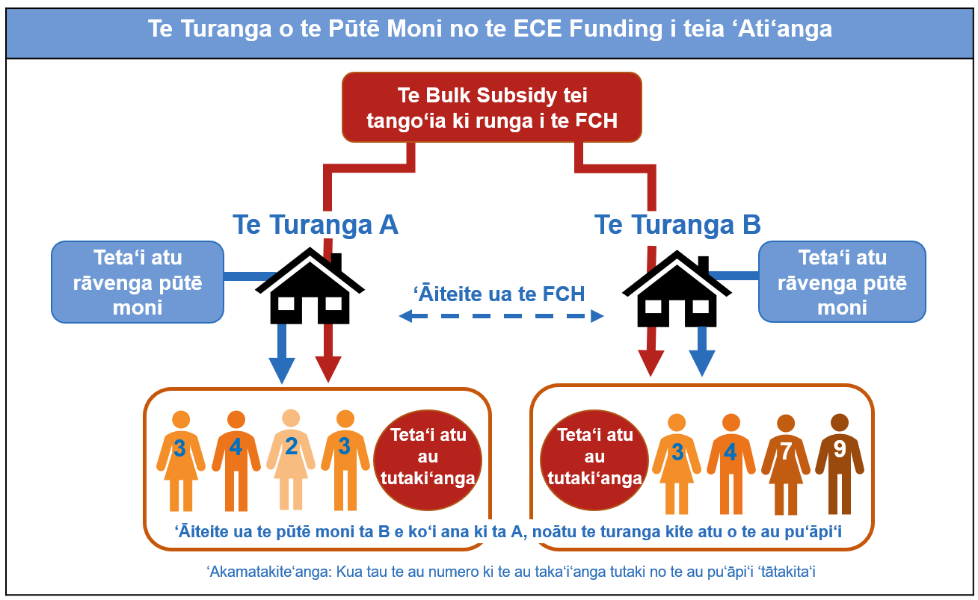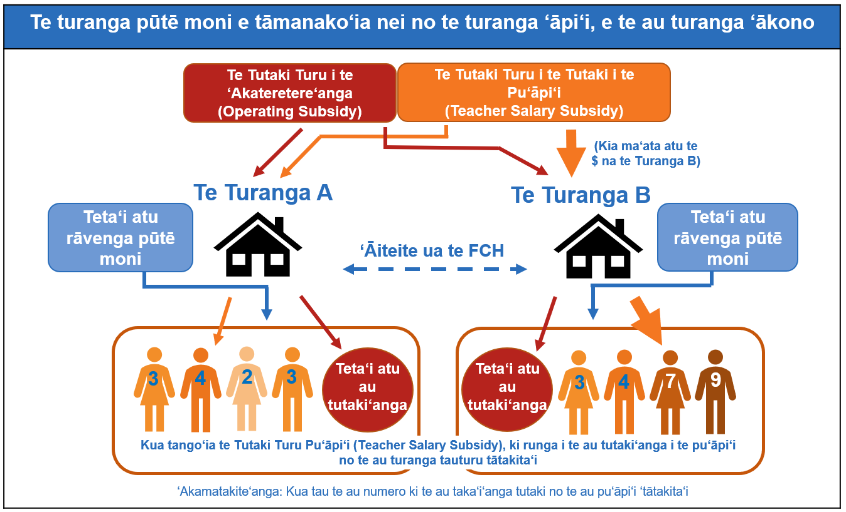
Element 1: Te ‘akatanotano‘anga i te tika‘anga FTTE no te Teacher Salary Subsidy
(me kore ra ‘ē‘ia pu‘āpi‘i ka tāru‘ia atu ki roto’)
Ko te ‘akatinamou‘anga i te tika‘anga FTTE no te pu‘āpi‘i e pēpa pu‘āpi‘i to ratou, te taka‘i‘anga mua no te ‘akatinamou‘anga i te TSS no te au turanga tātakita‘i. Te tāmanako atu nei matou, kia ‘akatanotano‘ia teia tika‘anga no te au turanga tātakita‘i, tei tango‘ia ki runga i te:
- Forecast FCH: Ko te tārē‘anga teia i te funded child hours (FCHs) na roto i teta‘i ‘ā marama.
- Entitlement ratio: Ko te tārē‘anga teia i te tamariki ki te pu‘āpi‘i ‘okota‘i, e pēpa pu‘āpi‘i to ratou. Te meitaki atu o te tārē‘anga (ratio) tei tā‘anga‘anga‘ia, ko te ma‘ata atu ia o te au pu‘āpi‘i te ka tu i te tika‘anga FTTE no te tārē‘anga ‘āiteite ki te FCHs. Ko te ‘āite‘anga i reira, na roto i te ‘akapapa‘anga i teta‘i tārē‘anga (ratio) tau no te TSS, kia ‘āiteite i reira te au turanga pouroa.

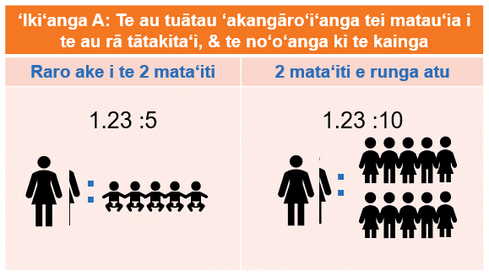
Te au takai‘anga tau no te ‘akano‘o‘anga i te tārē‘anga (ratio) Entitlement
Te ‘irinaki nei matou i te ‘akano‘o i te tārē‘anga (ratio) na roto i teta‘i o nga ‘iki‘anga e rua. Ka ‘akamata teia, na roto i te tārē‘anga (ratio) tangata mama‘ata-ki-te-tamaiti, ei ‘akamata‘anga, māri ra, ko te au pu‘āpi‘i ua, e pēpa pu‘āpi‘i to ratou, kare e ko te aronga mama‘ata pouroa.
‘Iki‘anga A: teta‘i ravenga ‘statutory minimum’, e tei roto i teia te statutory leave, e te au tuātau ‘akangāro‘i no te au FTTE tātakita‘i. Ka ‘ōronga mai teia i te tārē‘anga (ratio) 1.232 aronga mama‘ata, ki te 5, me kore ra, 10 tamariki (tei runga ‘ua i te ‘akapupu‘anga tamariki tei raro ake i te 2 / runga ake i te 2-mata‘iti).
‘Iki‘anga B: teta‘i tārē‘anga (ratio) tei tere atu i te 1.232 aronga mama‘ata ki taua tārē‘anga tamariki rāi. Ka ‘akamata teia ‘iki‘anga, i te tārē i te tutaki no te ‘iki‘anga kitena-kore‘ia (discretionary choices)(teia te ‘akara‘anga, te tuātau kare koe i mua i te tamariki, e te ‘akapapa‘anga tei tere atu i tei anoano‘ia (minimum), kia taeria te tārē‘anga (ratio) ‘inangaro‘ia).

Element 2: Te ‘akatanotano‘anga i te management funding no te Teacher Salary Subsidy
Kua ko‘u‘ia te au turanga ‘akateretere e āru mai nei, ki raro ake i te existing parity funding rates i teia ‘ati‘anga. Kua tango‘ia teia ki runga i te au management roles KTCA ‘K2-K4’.
- K2 - kua tā‘anga‘anga‘ia ei ‘aka‘aere i teta‘i turanga, e kare i te tangata ‘anga‘anga K3 me kore ra, i te K4 (mei te mānītia o te puna).
- K3 - tā‘anga‘anga‘ia i te rave i te au turu‘anga tukatau, arataki‘anga, e te au turanga ‘akateretere‘anga. Te ‘aka‘aere i te aronga ‘anga‘anga K2.
- K4 - tā‘anga‘anga‘ia i te ‘aka‘aere i te aronga ‘anga‘anga K3.
E rua ‘iki‘anga i roto i te tāmanako‘anga no te funding management, e te leadership roles:
‘Iki‘anga A: Te ‘iki‘anga K2-K4 . I roto i teia ‘iki‘anga, ka kite te turanga ‘āpi‘i, e te au turanga tiaki tamariki, i te au pu‘āpi‘i e pēpa pu‘āpi‘i to ratou, te rave ra i te au turanga ‘aka‘aere i raro ake i te au taka‘i‘anga tutaki K2, K3, e te K4 i raro ake i te KTCA. Ka ‘akatanotano‘ia teta‘i tika‘anga FTTE kia kite‘ia te tārē‘anga o te FTTE, no te au turanga tātakita‘i, i raro ake i teta‘i tārē‘anga (ratio) ‘akateretere‘anga.
Te ‘akano‘ono‘o‘anga i te tārē‘anga (ratio) ‘akateretere‘anga
Mei te ‘akapapa‘anga i raro ake nei, te tika‘anga no te tārē‘anga (ratio) ‘akateretere‘anga i raro ake i te ‘Iki‘anga A. E vāito‘anga ‘ōu, no teta‘i tamaiti tei raro ake i te tārē‘anga pūtē moni, i te tauturu i teia tārē‘anga (ratio) ‘ōu, e te karanga‘ia nei e, ko te 75,000 funded child hours per year. Ko te au turanga ‘ua kua tere atu i te ‘okota‘i turanga, te ka tau no te pūtē moni K3, e te K4.
Te taka‘i‘anga tutaki no te ‘akateretere‘anga | Tārē‘anga (ratio)
K2 | 1:50 (‘akateretere‘anga FTTE no te funded child places)
K3 | 1:300 (‘akateretere‘anga FTTE no te funded child places)
K4 | 1:6 (te tārē‘anga (ratio) K4 ki te K3)
‘Iki‘anga B: Te K2, e te ‘iki‘anga no te management funding. I roto i teia ‘iki‘anga, ka ‘ōronga‘ia ‘okota‘i turanga K2 tei tutaki‘ia ki raro ake i teta‘i enhanced K2 pay rate, ki te au turanga ‘āpi‘i, e te au turanga tiaki tamariki tātakita‘i. Ki runga‘o i teia, ka ‘anga‘ia te management funding, te ka tutaki i te au turanga i teta‘i tutaki‘anga tei ‘akatinamou‘ia no te FCH tātakita‘i, e te flexed, tei tango‘ia ki runga i te ma‘ata o te FCH, i roto i te au funding period tātakita‘i. Kare te pūtē moni e tāru‘ia ki roto i te au fixed salary top ups, ‘inārā, ka tā‘anga‘anga‘ia te pūtē moni na te au pu‘āpi‘i, e pēpa pu‘āpi‘i to ratou, te rave ra i te au turanga ‘akateretere‘anga.

Element 3: Te ‘akatinamou‘anga i te funding tei ‘ōronga‘ia na roto i te TSS
I muri ake i te ‘akatanotano‘anga i te elements 1, e te 2, no teta‘i turanga, te tāmanako atu nei matou, kia tango‘ia te pūtē moni a te TSS i roto i te au ‘ā-marama tātakita‘i, ki runga i te au taka‘i‘anga e āru mai nei.
- Te ma‘ani‘anga i teta‘i weighted average pay (kua tango‘ia ki runga i te KTCA pay rates) no te pu‘āpi‘i FTTE i roto i te turanga o taua tuātau.
- Te ‘akatano‘anga i te tika‘anga FTTE, ki te FTTE tika i ko i teta‘i turanga. Ko te rāvenga ‘akatanotano‘anga teia i te patene a te au pu‘āpi‘i e pēpa pu‘āpi‘i to ratou tei roto i teta‘i turanga.
- Te ‘akatopa‘anga i te tārē‘anga o te FTTEs kia tau ki teta‘i ua atu part- funded child hours (i te mea e, e tu‘anga ua rāi tei tutaki‘ia no te ECE Subsidy hours, i teia ‘ati‘anga). Ka tā‘anga‘anga teia, i teta‘i tu‘anga-kua-‘akano‘o-takere ia, kia tau ki te taka‘i‘anga o te part-funding.
- Te ‘akama‘ata‘anga i te FTTE entitlement, pērā katoa te adjusted FTTEs, na roto i te ‘akatanotano‘anga i te tutaki `āverēti a te pu‘api‘i ki raro ake i te au taka‘i‘anga i runga ake nei, i te ‘akatupu i te tu‘anga non-management teacher o te TSS.
- Te ‘akatinamou‘anga i te management funding (‘ākara‘ia te Element 2). Ka ‘akatopa‘ia mai te tutaki management, kia tau ki te part-funded child hours, mei tei roto tikāi i te Taka‘i‘anga 3.
Ka ‘washed up‘ ‘ia te TSS funding i te ‘openga o te funding period, kia tau ki te au mea tūkē i rotopu i te actual, e te predicted advance funding. Ko teia rāi te rāvenga e tā‘anga‘anga‘ia ana, i te ‘akatano i te advance funded early learning subsidies, i teia ‘ati‘anga.
Ka ‘akape‘ea i reira te ‘akatanotano‘anga kia ‘akatinamou‘ia te weighted average pay, i roto i teta‘i turanga TSS? (Taka‘i‘anga 1)
Ka ‘inangaro te Taka‘i‘anga 1 i te weighted average pay (tei tango‘ia ki runga i te KTCA pay rates) no te au turanga tātakita‘i. Te kimi atu nei te tāmanako‘anga i to kotou manako, no runga i nga rāvenga e rua, no te ‘iki‘anga i te weighted average:
- Te ‘āverēti‘anga i te tutaki no te au pu‘āpi‘i katoatoa e pēpā pu‘āpi‘i to ratou, i roto i teta‘i turanga, i roto i te tuātau ‘ā-marama. Ka weighted ‘ia teia, ki runga i te tumu i tā‘anga‘anga‘ia ei te pu‘āpi‘i FTTE tātakita‘i.
- Te ‘akatika‘anga i te au turanga tātakita‘i, i te ‘iki i te au pu‘āpi‘i FTTEs, te ka tutaki‘ia i raro ake i te tika‘anga TSS. Tei te turanga rāi te tika, i te tārē‘anga o te FTTE o te au pu‘āpi‘i tātakita‘i, te ka tāru‘ia ki roto.
E ‘akape‘ea‘ia ana te ‘akatano‘anga i te FTTE pu‘āpi‘i ki te tika‘anga FTTE? (Taka‘i‘anga 2)
Te kimi atu nei te tāmanako‘anga i to kotou manako, no runga i nga rāvenga e rua, no te ‘akatimamou‘anga i te rāvenga a teta‘i turanga i te ‘akakī‘anga i tōna tika‘anga FTTE - ko te element teia te ‘ākara ra i te tu‘anga pu‘āpi‘i e pēpa pu‘āpi‘i to ratou (mei te au certificated teacher bands i roto i te turanga i teia ‘ati‘anga):
- Tā‘anga‘anga‘ia te katoa‘anga o te pu‘āpi‘i FTTE te ‘anga‘anga ra na roto i te tuātau tei tutaki‘ia, te ‘inangaro‘ia ra no te regulated ratio na roto i te au funded e te unfunded child hours.
- Tā‘anga‘anga‘ia te au ‘akaue‘anga ‘staff hour count’ i te ‘ātui i te teacher hours ki te child hours – e tārē ana teia rāvenga i te au pu‘āpi‘i e pēpa pu‘api‘i to ratou, e tā‘anga‘anga putuputu ‘ia ana, me ‘aka‘āite‘ia ki te ‘iki‘anga mua. E ma‘ata ake ta teia iki‘anga aronga ‘anga‘anga FTTE, i te tā‘anga‘anga i te tika‘anga FTTE kia pou.
Te tu‘anga public funding no te part-funded hours (Taka‘i‘anga 3, e te 5)
Te ‘akatopa nei (scale down) te taka‘i‘anga 3 i roto i te TSS funding process, i te tika‘anga FTTE na roto i te tā‘anga‘anga‘anga i teta‘i tu‘anga. Ka ‘akaāri mai teia tu‘anga i te kavamani, me kore ra, te ‘ōronga a te ‘iti tangata, ki te part-funded hours. E ‘irinaki‘ia ana e, te vai ‘ua nei rāi teia tu‘anga, māri ra, kare rava e patene tika, i ‘akano‘o‘ia ana. Na te ‘akano‘o‘anga i teia tu‘anga e ‘aka‘oro i te vā‘i‘anga o te au funding katoatoa, ki roto i te TSS, e te OS. Kare i tau‘ī te katoa‘nga o te funding no te au turanga pouroa, i te mea e, ko te ‘irinaki‘anga‘ia o te tāmanako‘anga. Te ‘iri‘iri manako nei matou, no runga i nga rāvenga e rua, i te ma‘ani‘anga i teta‘i ‘ōronga‘anga na te ‘iti tangata.
‘Iki‘anga A: Teta‘i tu‘anga tei ‘akano‘o‘ia na te kavamani, no te part funded hours. Te tāmanako nei matou i te ‘akano‘o i teia tu‘anga ki te 80%, e teta‘i 20% no va‘o mai (teia te ‘ākara‘anga, no roto mai i te fees a te au metua).
‘Iki‘anga B: Te ‘akatinamou‘anga i teta‘i tutaki‘anga mātūtū no va‘o mai, noātu te tutaki `āverēti o te pu‘āpi‘i. Tei roto i teia, te ‘akatanotano‘anga i te absolute private contribution, noātu te taka‘i‘anga tutaki ‘āverēti i roto i teta‘i turanga. Ko te ‘āite‘anga i teia i reira, teia te ‘ākara‘anga, me e $10 i te ora, te tutaki i te pu‘āpi‘i, ka ‘ōronga pa‘a te kavamani e $8, ko te ‘āite‘anga i reira, ka anoano‘ia te turanga, kia ‘ōronga e $2. Me kake ‘ua ake i reira te tutaki ‘averēti no te pu‘āpi‘i, a te reira turanga ki te $20 i te ora, noātu e ka vai mātūtū te tika‘anga FTTE, ka tutaki i reira te kavamani, e $18 e ka ‘ōronga ‘ua atu rāi te turanga i te $2.
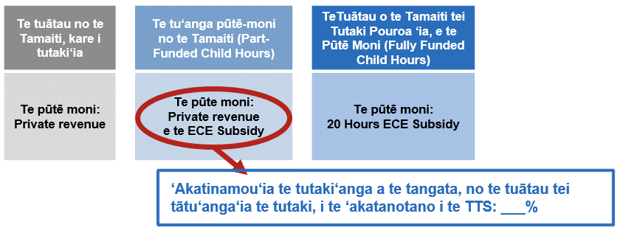
Element 4: Te ‘akatanotano‘anga i te Operating Subsidy
Ka ‘akaruke te tāmanako‘anga i te OS ei ‘ōronga‘anga no te tutaki i teta‘i atu au tutaki‘anga ke a te turanga ‘āpi‘i, e te au turanga ‘ākono tamariki. Ka tutaki‘ia te reira ei set rate per hour no te au turanga pouroa. Tei te au turanga rāi te tika, no runga i te tā‘anga‘anga‘anga i te OS funding.
Tei runga ‘ua te OS rate, i te katoa‘anga o te TSS, te ka ‘inangaro‘ia no te au turanga pouroa. Ka tupu teia, no te mea, ka ‘akatanotano‘ia na mua te overall system funding no te TSS, e ka ‘akatanotano‘ia te toenga no te OS rates. I te mea e, kua ‘akapapa‘ia te TSS no teta‘i TSS ma‘ata atu, ka ‘akatopa‘ia mai i reira te OS funding rates.
Te ‘akakore‘anga i te ‘Under 2’ e te ‘2 and over’ distinction
Kare a te OS rates distinct ‘under 2’ e te ‘2 and over’ rates. Ko te‘akaāri‘anga mai i te tūkē i rotopu i te tutaki‘anga i te au pu`āpi‘i e pēpa pu‘āpi‘i to ratou, no te au turanga, e, e regulated ratios kē atu ta ratou, no te au pupu mata‘iti tātakita‘i, te tūkē i te moni i rotopu i teia au rates, i roto i te turanga i teia ‘ati‘anga. Ka ‘ākara te TSS, i te tūkē o te tutaki‘anga pu‘āpi‘i tei roto i te au tārē‘anga (ratios) (mei tērā ‘ua ra i reira, te tūkē i te tārē‘anga o te pu‘āpi‘i no te au pupu mata‘iti tūkētūkē). Ka ‘akatika i reira teia, kia karanga‘ia te OS, ei fully-funded rate, e te part-funded rate anake.

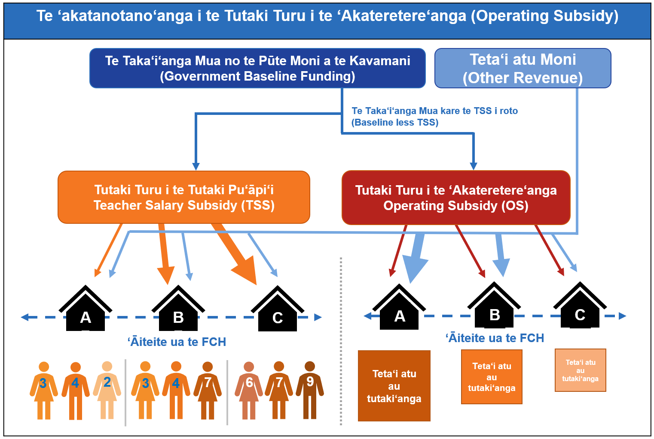

Ka ‘akape‘ea i reira te service funding i raro ake i te turanga ‘ōu e tāmanako‘ia nei
Ka tauī te rāvenga ‘ōu i te average government funding per FCH no te au turanga– i roto i teta‘i au ‘ākara‘anga, ka topa mai te average funding per hour, no teta‘i turanga i raro ake i te ‘aka‘aere‘anga o teia tuātau. Ka anoano‘ia pa‘a teia au turanga, kia tauī i ta ratou operating model, i te ‘aka‘aere i teia tauī‘anga. Ka pāruru teia rāvenga ‘ōu, e te tutaki‘anga tau e ‘inangaro‘ia nei, i te au turanga i te tā‘anga‘anga‘anga i ta ratou total funding, i te mea e, ka tā‘anga‘anga‘ia te TSS no te tutaki pu‘āpi‘i. Ko te ‘āite‘anga i teia i reira, teia te ‘ākara‘anga, ka anoano‘ia pa‘a te au turanga te ‘anga‘anga nei ki runga ake i te funded ratio levels o te au pu‘āpi‘i, kia tāmanako i te ‘akatopa i te tārē‘anga o te pu‘āpi‘i, me kore ra, i te kimi pūtē moni ki va‘o ake i te TSS.

Tāmanako‘anga– Te au turanga tei roto i te ngutu‘are
Te ‘o‘ora atu nei te pēpa ‘iri‘iri‘anga manako, i nga ‘iki‘anga e rua, te ka tauturu kia pu‘apinga atu te tutaki, no te aronga ‘akateretere (coordinator) i te au turanga tei roto i te ngutu‘are.
Ka ‘akapae te rāvenga mua (‘Iki‘anga A), e ka tu‘atu‘a ‘aka‘ōu i te early learning subsidy funding i teia tuātau, no te au turanga tei roto i te ngutu‘are, na roto i teta‘i coordinator salary subsidy (CSS) ‘ōu. ‘Oroā ‘āiteite atu rāi teia, ki te rāvenga a te TSS, no te turanga ‘āpi‘i, e te au turanga ‘ākono tamariki. No te tutaki anake te CSS i te tangata ‘akateretere. Te tāmanako nei matou i te tārē‘anga (ratio) ‘okota‘i tangata ‘akateretere full- time equivalent FTE, ki te 50 funded child places (mei te 75,000 FCH i te mata‘iti). Ko te ‘āite‘anga i teia i reira, kia ‘anga‘anga ta‘okota‘i te CSS e te FCH – ka ‘ōronga‘ia te funding no teta‘i tu‘anga anake o te FTE, te turanga tei raro ake i te 75,000 FCH.
Ka ‘akakake te rua o te rāvenga (‘Iki‘anga B) i te subsidies e vai nei, kia tau ki te kake i te tutaki‘anga tangata ‘akateretere. Ka tau pa‘a teia rāvenga, no te mea, ‘okota‘i rāi taka‘i‘anga tutaki moni no te aronga ‘akateretere, e ka pāruru teia i te au tutaki‘anga tūkētūkē i te aronga ‘akateretere, na roto i te au turanga. Mei te rāvenga mua rāi, tei runga te ma‘ata o te funding i te FCH.
Ea‘a i reira te taka‘i‘anga minimum pay, tei tau no te tutaki i te au ‘akateretere?
I raro ake i te ‘iki‘anga A, e toru au ‘iki‘anga no te ‘akano‘ono‘o‘anga i te taka‘i‘anga tutaki, ka anoano‘ia te au turanga kia tutaki i te au ‘akateretere. Ka tau teia ki te arataki‘anga, e te au ‘irinaki‘anga ki runga i te au ‘akateretere. Ko teia:
- Te taka‘i‘anga “K2” no roto mai i te KTCA
- Teta‘i taka‘i‘anga tei ‘akano‘o‘ia ki raro ake i te “K2” māri ra, ki runga ake i te Taka‘i‘anga 11 o te “K1” base-teacher rate, mei roto mai i te KTCA
- Teta‘i taka‘i‘anga tei ‘akano‘o‘ia ki te Taka‘i‘anga 11 o te “K1” base-teacher rate mei roto mai i te KTCA
Ka tutaki‘ia teia au rates, noātu te pēpa kite, e te roa o te kite i te ‘anga‘anga. Ko te CSS funding te mea ma‘atama‘ata rava atu, e te ‘iki‘anga tutaki ma‘ata rava atu (‘iki‘anga 1), āru‘ia mai e nga ‘iki‘anga 2 e te 3.
Ea‘a i reira te rāvenga no te aronga ‘inangaro po‘itirere‘ia?
‘Akakite mai i to‘ou manako, no runga i te ma‘ata o te taime e tau kia tāniuniu‘ia te aronga ‘akateretere no te ‘anga‘anga, e te rāvenga tutaki‘anga a te turanga, me tāniuniu‘ia atu te au ‘akateretere. Na teia e tauturu i te CSS, me ka tāru rāi ratou i teta‘i sub-component no te tutaki‘anga no teia au tāniuniu‘ia‘anga.
E tau rāi kia tāru‘ia te au mānītia o te aronga ‘akateretere ki roto i te tika‘anga coordinator FTTE?
Ka rauka rāi i te tāru i te au ‘akateretere i roto i te au turanga i roto i te ngutu‘are, ki roto i te tutaki‘anga tau (pay parity). Ko teta‘i atu taka‘i‘anga teia, kare e ‘irinaki ki runga i te pēpa kite, me kore ra, i te roa o te kite i te ‘anga‘anga. Teia to matou manako, no te mea e tei te turanga rāi te tika, e kare i ‘āiteite ki te higher kindergarten management positions, kare i reira e tau kia ‘ōronga‘ia teta‘i specific funding allocated from the baseline, no ratou.

Ka ‘akape‘ea i te ‘akakite‘anga mai i to‘ou manako
E tau kia tatau koe i te katoa‘anga o te pēpa no runga i te ‘iri‘iri‘anga manako, i mua ake ka tuku mai ei i to‘ou manako, no runga i te au tāmanako‘anga. Tei roto i te reira, teta‘i atu au ‘akakitekite‘anga, e te au ‘akamārama‘anga, kare i roto i teia ‘akako‘uko‘u‘anga.
‘Akakī‘ia te kimikimi‘anga-kite tei runga i te ‘ātuitui roro uira, i te ‘akakite mai i to‘ou manako, no runga i te au tāmanako‘anga, na runga i te https://conversation.education.govt.nz/conversations/early-learning-pay-parity-funding-review.
Ka rauka katoa iā koe i te tuku mai i teta‘i tātā‘anga rito atu ki te:

ECE.PayParity@education.govt.nz
me kore ra,
ECE Pay Parity
Ministry of Education | Te Tāhuhu o te Mātauranga
PO Box 1666
Wellington 6140
Ka inangaro te Māraurau i to‘ou manako, i mua ake i te 11.59 i te po 23 o Mē, i te mata‘iti 2023.

Ko te ECE Subsidy hours, te part-funded hours i teia ‘ati‘anga – te ‘irinaki‘ia nei e, na teia e part-fund i te tutaki‘anga, i te tutaki i te rāvenga ECE na te kavamani. Te tutaki‘ia nei, i teia ‘ati‘anga, te fully-funded child hours, e te 20 Hours ECE Subsidy.

